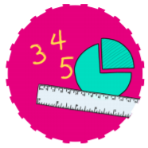


Communication and Language
Use a wider range of vocabulary relating to the topics we will cover.
Start a conversation with an adult or a friend and continue it for many turns.
Use longer sentences of four to six words.
Enjoy listening to longer stories and can remember much of what happens.



MATHS
Time - understand first/next
Experiment with their own symbols and marks as well as numerals.
Solve real world mathematical problems with numbers up to 5. Compare quantities using language: ‘more than’, ‘fewer than’.

Subitise to 3.

RE
Know that Christians believe that god loves everyone
Jesus’ stories. Which stories are special and why? Stories that have a message for us in them.

Nursery – Foundation Stage 1
Summer Term
Curious Creators

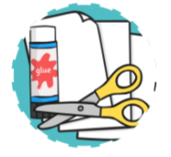



Understanding Our World
Know that there are different countries in the world and talk about the differences they have experienced or seen in photos
Developing our poppy area in the Eco garden
Comparing life in Africa and England
Tiny Tots Allotment development
Literacy
Develop their phonological awareness, so that they can: - spot and suggest rhymes - count or clap syllables in a word - recognise words with the same initial sound, such as money and mother

Use some of their print and letter knowledge in their early writing. For example: writing a pretend shopping list that starts at the top of the page; write ‘m’ for mummy.

Write some or all of their name.

Expressive Art and Design
Art Skill Sculpture – clay Handa’s bowl

Art Skill Textiles – Handa’s surprise.

Respond to music with movement.

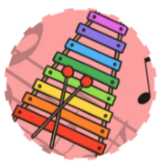
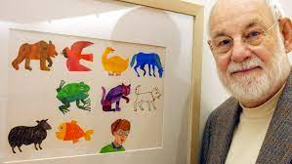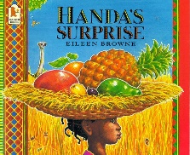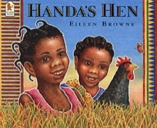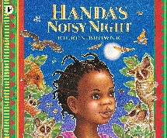
Physical Development
Using our new adventure playground to crawl, climb and slide.
Use one-handed tools and equipment, for example, making snips in paper with scissors.
Use a comfortable grip with good control when holding pens and pencils.
Match their developing physical skills to tasks and activities in the setting.
Make healthy choices about food, drink, activity and tooth brushing.
Spending quality learning time outdoors in our Tiny Tots Allotment


Experience
Visit to farm shop
Africa drum and dance

PSHE
Be able to use the toilet independently.

Can talk about the importance of hand washing.

Can talk about the importance of oral health.

Begin to understand how others might be feeling.
Play alongside new peers and ‘with’ familiar peers.

Show interest in their new peers.



Spanish
Learning how to say hello for the register at the start of sessions and goodbye when leaving.
Technology
Use Purple mash programme and Simple City on our Interactive board and Computer

