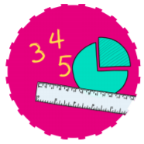


Communication and Language
Use a wider range of vocabulary relating to the topics we will cover.
Start a conversation with an adult or a friend and continue it for many turns.
Use longer sentences of four to six words.
Enjoy listening to longer stories and can remember much of what happens.



MATHS
Learning the value of numbers 1 – 5
Match me. Represent me. Subitise me. Identify me. Find my quantity. What makes me?
Number and place value

RE
Chinese New Year
Jesus’ stories. Which stories are special and why? Stories that have a message for us in them.

Nursery – Foundation Stage 1
Spring Term 1
Curious Creators





Literacy
Stories from our Author study of Eric Carle
Polar Bear, Polar Bear, What do you hear?
Brown Bear Brown Bear, What do you see?
Panda Bear Panda Bear, What do you see?
Leaf by Sandra Dieckmann

Understanding Our World
Know that there are different countries in the world and talk about the differences they have experienced or seen in photos
Look for signs of winter in our Eco garden
Global warming, endangered animals through topic and story books.

Expressive Art and Design
Play instruments with increasing control to express their feelings and ideas.
Respond to what they have heard, expressing their thoughts and feelings.

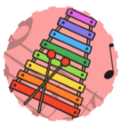
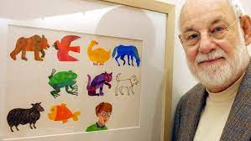
Physical Development
Using our new adventure playground to crawl, climb and slide.
Use one-handed tools and equipment, for example, making snips in paper with scissors.
Use a comfortable grip with good control when holding pens and pencils.
Match their developing physical skills to tasks and activities in the setting. For example, they decide whether to crawl, walk or run across a plank, depending on its length and width.


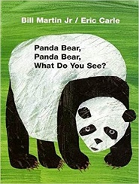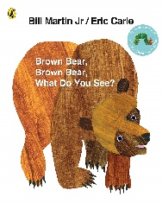
Experience
Chinese New Year
Visit to Tiny Town

PSHE
Find solutions to conflicts and rivalries. For example, accepting that not everyone can be Spider-Man in the game, and suggesting other ideas.
Increasingly follow rules, understanding why they are important and remember rules without needing an adult to remind them.
Understand gradually how others might be feeling.



Spanish
Learning how to say hello for the register at the start of sessions and goodbye when leaving.
Technology
Use Purple mash programme and Simple City on our Interactive board and Computer

