
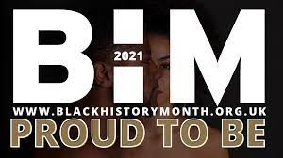


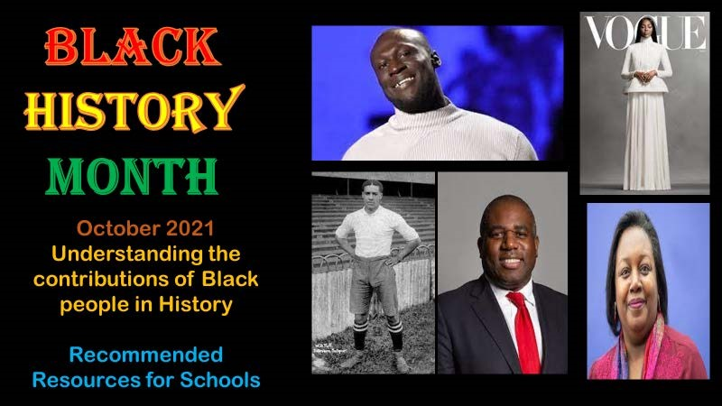


Black History Month 2021

-

Proud To B
e

F
ree resources as well as a Black History teaching pack
which
celebrates the contributions and dedication of the
Black Community in Britain. See website for details.

Weblinks | Black History for Schools (blackhistory4schools.com
)

A great website with
many useful links and resources/ presentations for KS2.

Blue Peter Black History Month | Spoken word poems for Black History Month 2020

Poetry
resources by black spoken word artists to celebrate Black History, commissioned by
Blue Peter

Black History Month

h
-
Teacher Resources - BBC Teac

A collection of resources which will allow you to explore the importance of black history, culture
and achievements.

Black History Month

-
CBBC - BB
C

and

Talk to your kids about Black History Month - CBeebies -

C
BB

Activities, stories and resources that support staff and parents to talk to children about Black
History.

Black History Month 2021

Event Info and Resources (twinkl.co.uk
-
)

Resources for BHM which provide great opportunities to highlight key moments in Black British
history.

Resources (100greatblackbritons.co.uk
)

The
100 Great Black Britons campaign includes useful learning resources to help teachers and
parents

)
Black History Matters | Resources to support your school. | Lilla Huset (thelillahuset.com

Includes a timeline of significant black historical events in the UK

