Spring Term Homework
During Spring term we would like you to complete four homework tasks. It is up to you to choose which tasks you want to complete however the one everybody must complete first is highlighted. All you need to do is return your homework on the dates below. Under each activity it tells you how many tea party tokens you could receive on completion of the task. Feel free to complete more if you want to!
Number 1: Thursday 7th January (highlighted activity)
Number 2: Wednesday 3rd February
Number 3: Tuesday 1st March
Number 4: Monday 21st March
Create a pair of underpants!  They could be made from material, a cake or a drawing. It’s up to you to be creative!  Up to 8 tea party tokens | Write a biography about either Helen Sharman or Tim Peake.    Up to 6 tea party tokens | Design a character that you could meet on a new planet.  Up to 3 tea party tokens | Create a fact file about a planet.  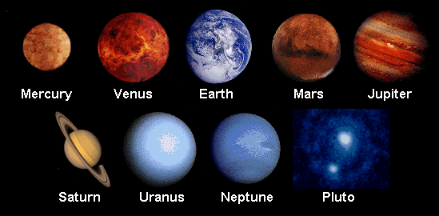  Up to 4 tea party tokens
Write a Moon diary for 2 weeks.    Up to 5 tea party tokens | Write your own space poem and decorate the page.  Up to 4 tea party tokens | Create a scene from ‘Aliens Love Underpants’. This could be in a shoe box, as a cake or a collage. Be creative!  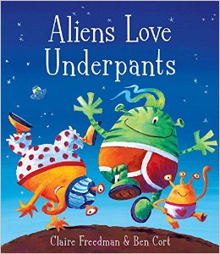  Up to 10 tea party tokens | Create a space quiz of up to ten questions, please provide the answers on a separate sheet.  Up to 6 tea party tokens

We are looking forward to seeing your homework
Good luck!
Mrs Pearce and Mrs Abbott

