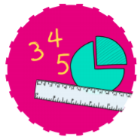


Communication and Language
Use a wider range of vocabulary relating to the topics we will cover.
Start a conversation with an adult or a friend and continue it for many turns.
Sing a large repertoire of new songs learned for topics and themes as well as traditional Nursery Rhymes and songs.



RE
The Story of Christmas.
Embed the value of Community.

MATHS
Counting in ascending order to ten and descending order to zero
Match and sort colour/shape
Compare size, mass, capacity.
Notice and recognise patterns

Nursery – Foundation Stage 1
Autumn Term 2
Curious Creators





Literacy:
Book will we look at:
Stories from our Author study of Eric Carle
The Nativity
Percy the Park Keeper (Seasonal themes)
The Lion Inside

Understanding Our World
Explore and talk about different forces they feel using magnets
Explore different materials with same/different properties.
Expressive Art and Design
Learning Christmas songs and play instruments to express themselves.
Black History Month
Continue exploring colour


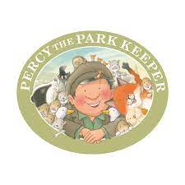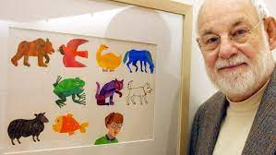
Physical Development
Using our new adventure playground to crawl, climb and slide. Throwing and catching beanbags for coordination.
Use one-handed tools and equipment, for example, making snips in paper with scissors.
Use a comfortable grip with good control when holding pens and pencils.
Show a preference for a dominant hand.

Experience
Visit from the Author of Grandad’s Wheels
Christmas performance – Carol concert

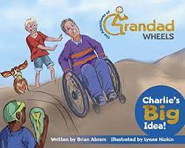
PSHE
Understand gradually how others might be feeling
Be increasingly independent in meeting their own care needs.
Increasingly follow rules understanding why they are important
Play with or more children extending and eloborating play ideas.



Technology
Use Purple mash programme on our computer and Simple City on our Interactive board
Spanish
Learning how to say hello for the register at the start of sessions.

